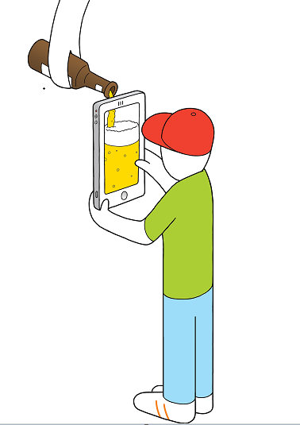
Registration Form

DIGITAL ALCOHOL MARKETING IN THE SPOTLIGHT
Conference in Amsterdam, the 19th September 2019
First name:
Family name:
Title:
Organization:
Country:
E-mail address:
Send these data before the first of July 2019 to: eucam@eucam.info
We will confirm your registration and send you an invoice.
Contact: European Centre for Monitoring Alcohol Marketing (EUCAM)
P.O. box 9769 | 3506 GT | Utrecht | The Netherlands

